Spaceship class (7:54)

<http://www.codeskulptor.org/#examples-spaceship.py>

1. Class “ImageInfo” stores information about the image.
2. Radius – to determine if there is a collision with other objects
3. Lifespan – it’s not for a ship but for other objects, e.g. missiles (that will disappear at some period of time)
4. Animated – we do not use for a ship as ship is a single static image. But other objects, e.g. explosions are animated (tiled images)

**# Partial example code for Spaceship**

import simplegui

class ImageInfo:

def __init__(self, center, size, radius = 0, lifespan = None, animated = False):

self.center = center

self.size = size

self.radius = radius

if lifespan:

self.lifespan = lifespan

else:

self.lifespan = float('inf')

self.animated = animated

def get_center(self):

return self.center

def get_size(self):

return self.size

def get_radius(self):

return self.radius

def get_lifespan(self):

return self.lifespan

def get_animated(self):

return self.animated

# art assets created by Kim Lathrop, may be freely re-used in non-commercial projects, please credit Kim

# ship image

ship_info = ImageInfo([45, 45], [90, 90], 35)

ship_image = simplegui.load_image("http://commondatastorage.googleapis.com/codeskulptor-assets/lathrop/double_ship.png")

# sound assets purchased from sounddogs.com, please do not redistribute

ship_thrust_sound = simplegui.load_sound("http://commondatastorage.googleapis.com/codeskulptor-assets/sounddogs/thrust.mp3")

# Ship class

class Ship:

def __init__(self, pos, vel, angle, image, info):

self.pos = [pos[0],pos[1]]

self.vel = [vel[0],vel[1]]

self.thrust = False

self.angle = angle

self.angle_vel = 0

self.image = image

self.image_center = info.get_center()

self.image_size = info.get_size()

self.radius = info.get_radius()

def draw(self,canvas):

canvas.draw_circle(self.pos, self.radius, 1, "White", "White")

def update(self):

pass

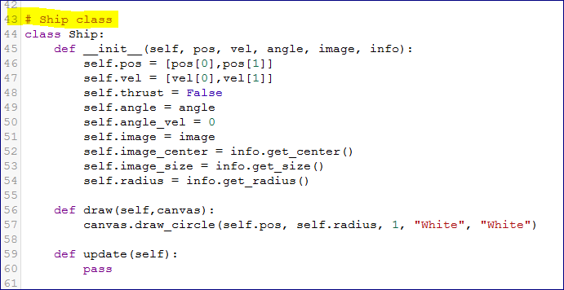

Angle – in radians

**self.thrust** = False 🡪 the ship doesn’t thrust in the beginning

**self.angle** = angle 🡪 the ship doesn’t rotate in the beginning

Draw method – replace circles with a space image based on whether the ship is standing or thrusting

Update method – update the position, the velocity, and the angle of the ship.

Class ship has to have all the methods inside:

* Turn thrusters on an off
* Shoot a missile
* Rotate the ship, and so forth

Sound (5:22)

<http://www.codeskulptor.org/#examples-sound.py>

In SimpleGUI you can load the sound and then you can:

1. Play
2. Pause
3. and Rewind

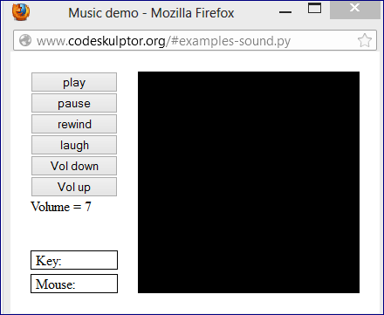

**# load some sounds**

music = simplegui.load_sound("http://commondatastorage.googleapis.com/codeskulptor-assets/Epoq-Lepidoptera.ogg")

laugh = simplegui.load_sound("http://commondatastorage.googleapis.com/codeskulptor-assets/Evillaugh.ogg")

**You can set a volume between 0 and 1**

0 – minimum

1 – maximum

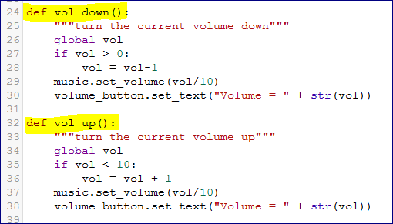

Sprite class (14:21)

Logical units of graphics organized inside the game.

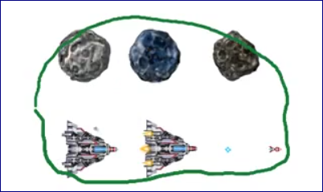

Here we see three sprites corresponding to an asteroid and two sprites corresponding to a ship.

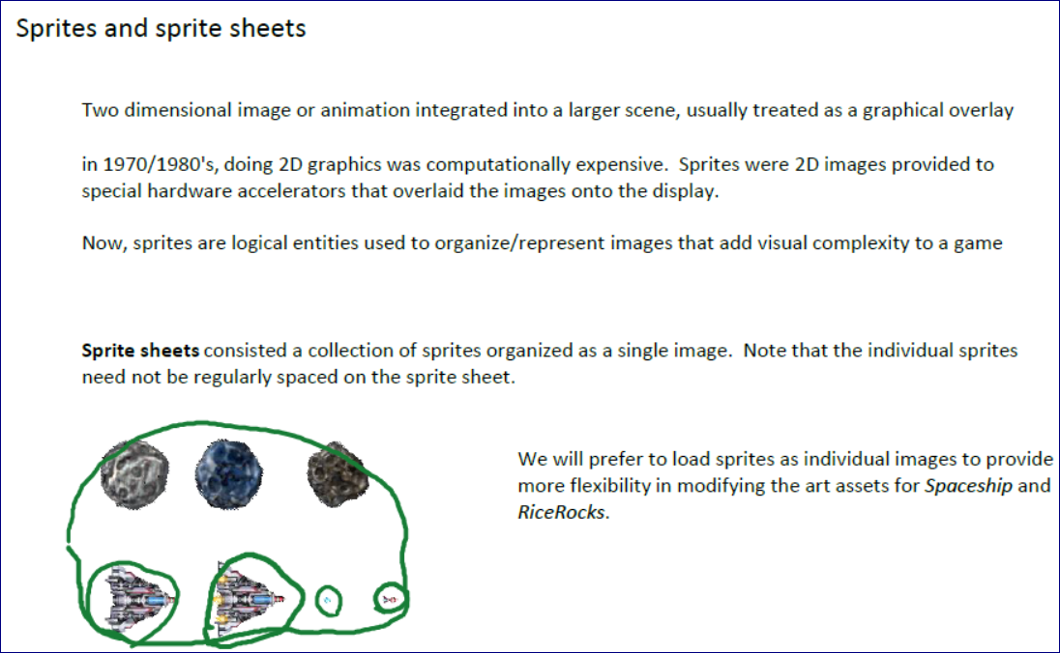

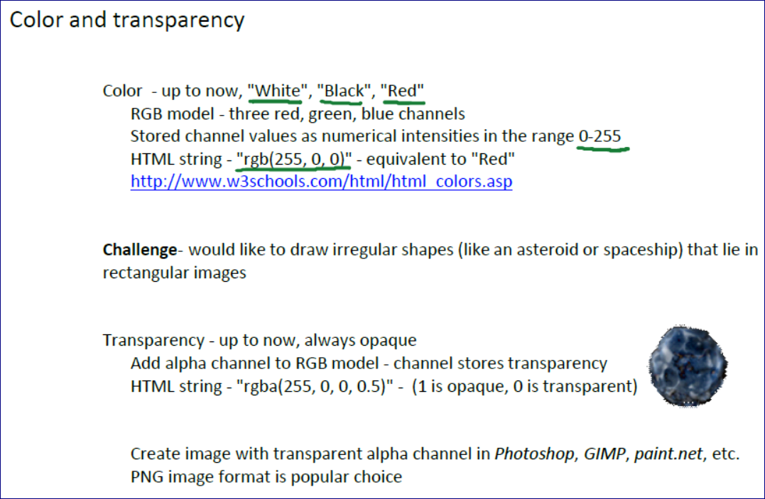

<http://www.w3schools.com/html/html_colors.asp>

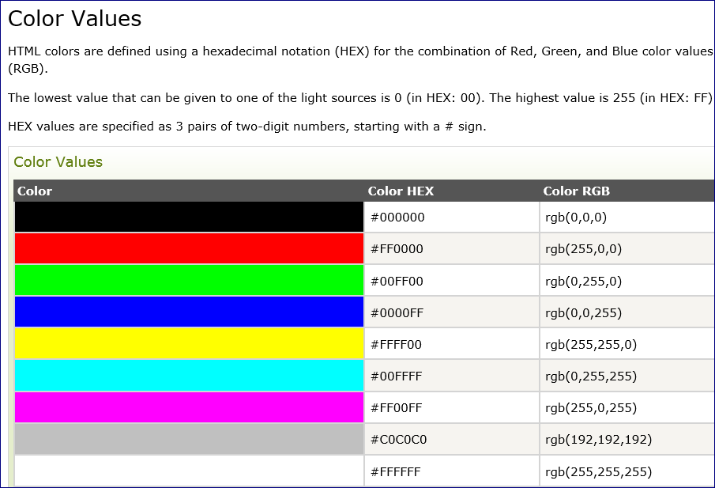

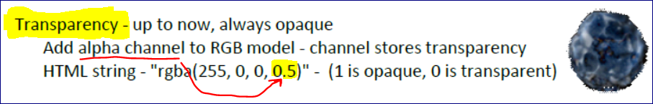

<http://www.codeskulptor.org/#examples-sprite_example.py>

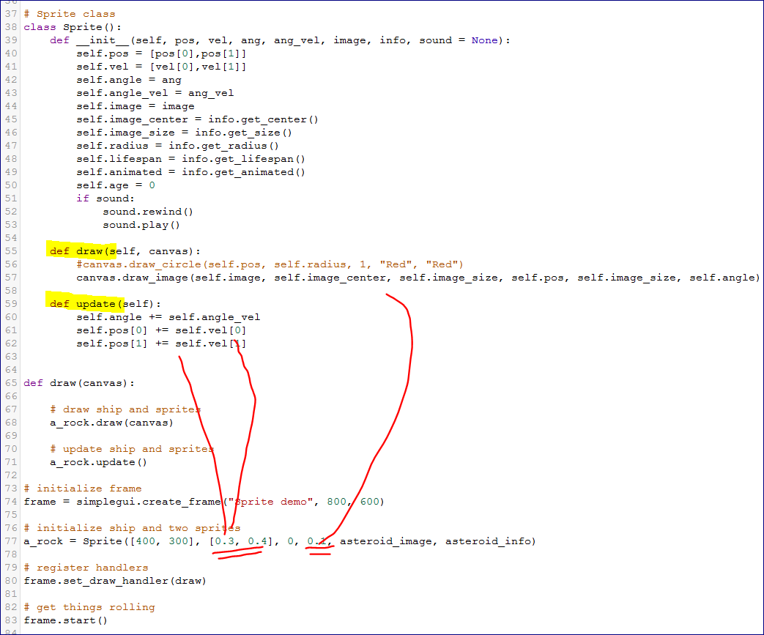

Spaceship (13:09)

<http://www.codeskulptor.org/#examples-spaceship_template.py>

